**:::ANALYSIS OF INDIA AGRICULTURE 1997-2021:::**

“Agriculture can trigger job-led economic growth, provided it becomes intellectually satisfying and economically rewarding. Contract farming can be promoted if it is structured on the basis of a win-win situation both for the producer and the purchaser.”

**::ANALYSIS AND VISUALISATIONS ::**

**DASHBOARD 1**

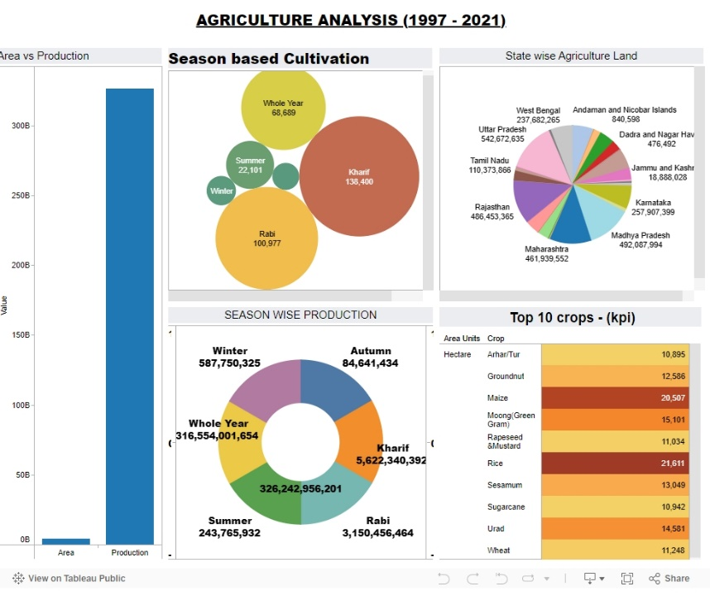

**DASHBOARD 2**

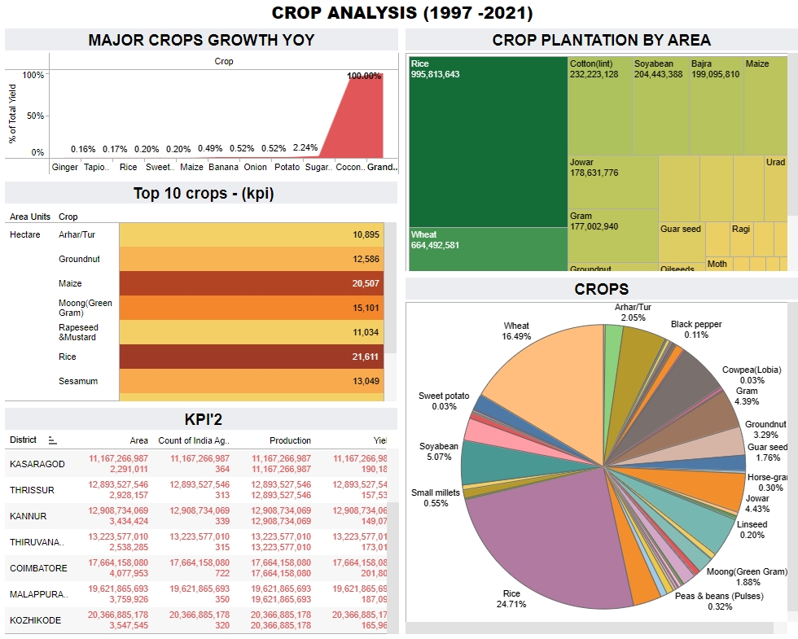

Let’s delve into the evolution of Indian agriculture from 1997 to 2021. 🌾 Overview: India has a rich agricultural heritage and is one of the world’s major agricultural producers. The sector plays a crucial role in the country’s economy, providing livelihoods to millions of people. Key Trends and Developments: 1997-2000: India faced challenges related to food security, crop diversification, and sustainable practices. The Green Revolution continued to impact crop yields. 2000-2010: Technological advancements led to increased productivity. Horticulture gained prominence alongside traditional crops. Organic farming and precision agriculture gained attention. 2010-2021: Climate change became a critical concern, affecting monsoons and crop patterns. Government initiatives focused on improving irrigation, soil health, and market access. Digital platforms facilitated information dissemination and market linkages. Crop diversification expanded to include pulses, oilseeds, and fruits. Sustainable practices gained momentum. Key Statistics: India has the world’s largest: Cattle herd (buffaloes) Area planted for wheat, rice, and cotton Production of milk, pulses, and spices It is the second-largest producer of: Fruits, vegetables, tea, farmed fish, sugarcane, wheat, rice, cotton, and sugar1. Challenges Faced: Small landholdings: Most farmers have small plots, limiting economies of scale. Water scarcity: Erratic monsoons and depleting groundwater pose challenges. Market access: Farmers need better access to markets and fair prices. Climate resilience: Adapting to changing weather patterns is crucial. Future Prospects: Technology adoption: Continued use of technology for precision farming. Sustainable practices: Promoting organic farming and soil health. Market reforms: Strengthening supply chains and reducing intermediaries. Climate-smart agriculture: Resilience to climate change. Remember, Indian agriculture is a dynamic field, and these trends provide a snapshot of its journey over the years. 🌱

**:::STORY 1:::**

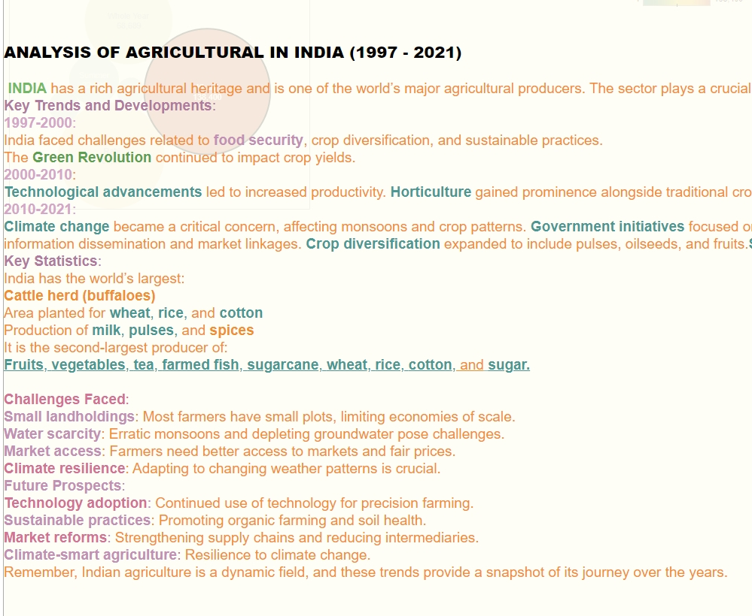

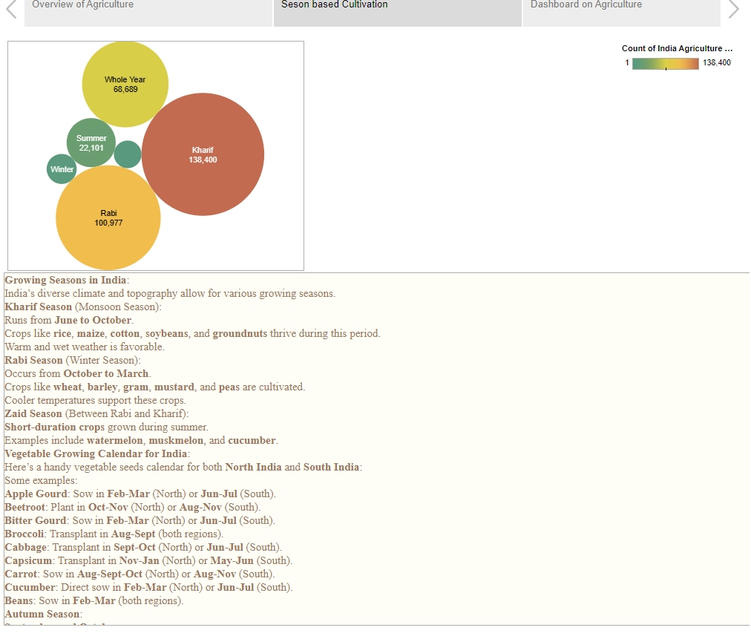

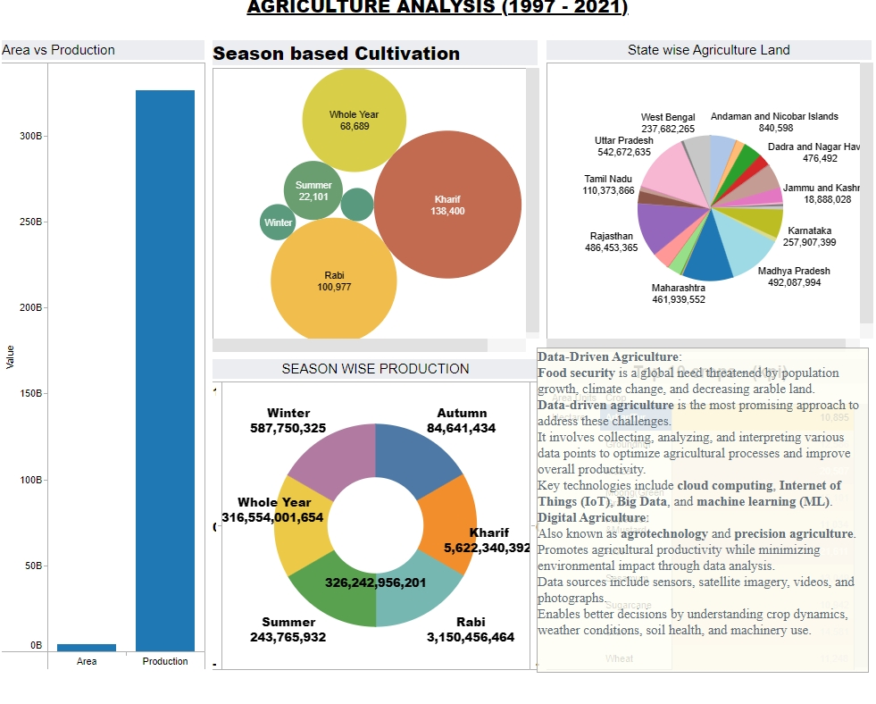

Let’s explore season-based cultivation in India. 🌱 Growing Seasons in India: India’s diverse climate and topography allow for various growing seasons. Kharif Season (Monsoon Season): Runs from June to October. Crops like rice, maize, cotton, soybeans, and groundnuts thrive during this period. Warm and wet weather is favorable. Rabi Season (Winter Season): Occurs from October to March. Crops like wheat, barley, gram, mustard, and peas are cultivated. Cooler temperatures support these crops. Zaid Season (Between Rabi and Kharif): Short-duration crops grown during summer. Examples include watermelon, muskmelon, and cucumber. Vegetable Growing Calendar for India: Here’s a handy vegetable seeds calendar for both North India and South India: Some examples: Apple Gourd: Sow in Feb-Mar (North) or Jun-Jul (South). Beetroot: Plant in Oct-Nov (North) or Aug-Nov (South). Bitter Gourd: Sow in Feb-Mar (North) or Jun-Jul (South). Broccoli: Transplant in Aug-Sept (both regions). Cabbage: Transplant in Sept-Oct (North) or Jun-Jul (South). Capsicum: Transplant in Nov-Jan (North) or May-Jun (South). Carrot: Sow in Aug-Sept-Oct (North) or Aug-Nov (South). Cucumber: Direct sow in Feb-Mar (North) or Jun-Jul (South). Beans: Sow in Feb-Mar (both regions). Autumn Season: September and October: Cooler temperatures compared to summers. Ideal for crops like lettuce, peas, onions, and spinach. Remember, understanding the growing seasons helps farmers plan their crop cycles effectively! 🌿

**:::STORY 2:::**

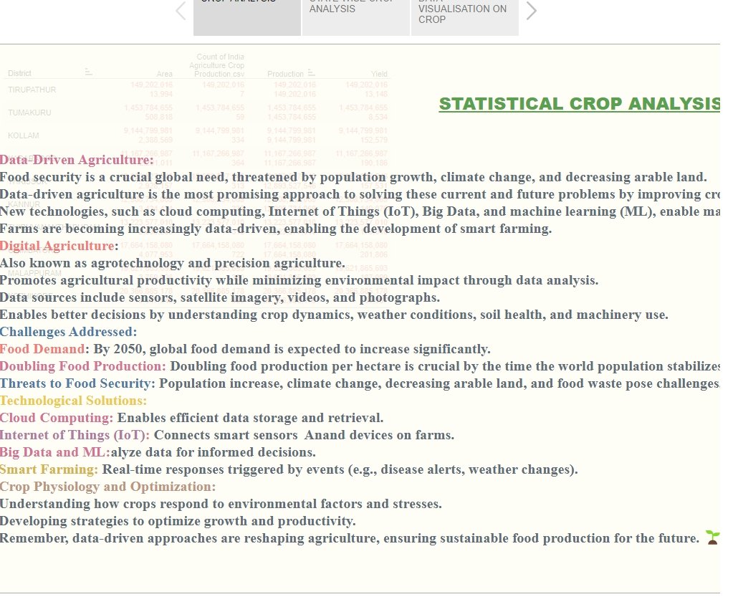

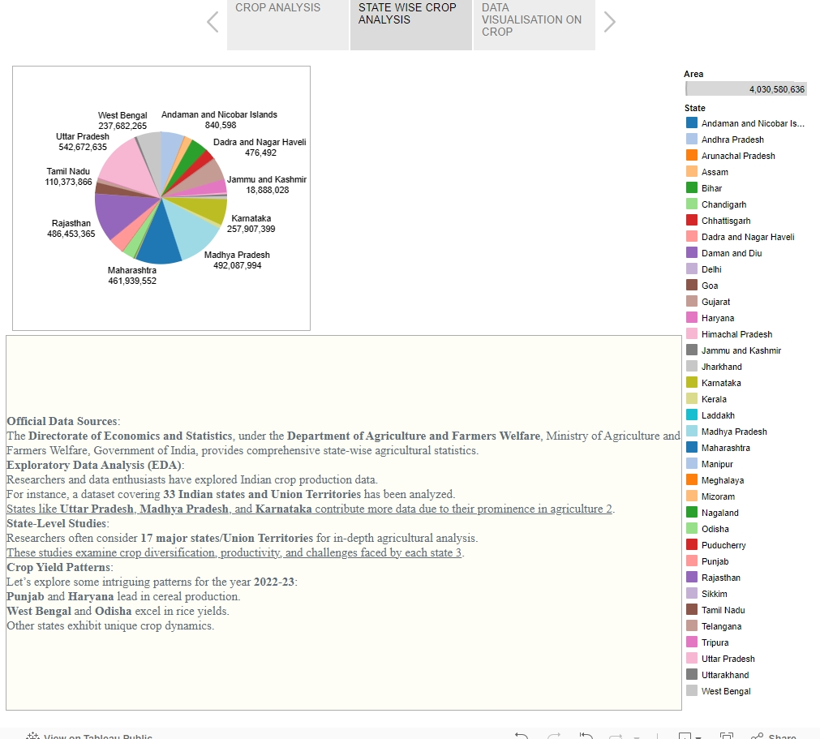



Rice-Based Cropping Systems: Rice is a major staple crop in India. Kharif season (wet-season, roughly July-December) witnesses significant rice cultivation. Rabi season (dry-season, roughly January-June) also sees rice cultivation in several states. Approximately 55% of India’s rice crop is irrigated. Irrigation levels vary across states (from <50% in Madhya Pradesh to >90% in Punjab, Tamil Nadu, Andhra Pradesh, and Haryana). Cropping systems involving rice include rotations with cereals, pulses, oilseeds, cotton, sugarcane, and vegetables. Intercropping of rice with compatible crops (e.g., blackgram, greengram, sesame) is common under upland conditions. Major Crops in India: Food Crops: Rice, Wheat, Millets, Maize, and Pulses. Cash Crops: Sugarcane, Oilseeds, Horticulture Crops, Tea, Coffee, Rubber, Cotton, and Jute. Crop Rotations and Practices: Mixed Varietal Cropping of Rice: In West Bengal, early rice seeds are mixed with late-maturing deep water rice to mitigate flood risks. Growing a mixture of autumn and winter rice varieties in Tamil Nadu and Kerala. Intercropping Rice with Other Crops: Common practice in the north and northeastern regions. Rice intercropped with blackgram, greengram, sesame, maize, or other minor millets. Future Strategies: Technology Adoption: Precision farming, organic practices. Market Reforms: Strengthening supply chains. Climate-Smart Agriculture: Building resilience to changing weather patterns. Remember, each crop is part of a larger system, and sustainable practices are essential for India’s agricultural future.

**\*\*THIS IS OUR PROJECT ON TOPIC LITERACY RATE IN INDIA-2021 BY**

**BHANUPRAKASH SINGAMPALLI(TEAM LEADER)**

**THOMAS SEERAPU(TEAM MEMBER)**

**S.K.S.R.KOUSHIK(TEAM MEMBER)**

**SWAMY SETTI(TEAM MEMBER)**

**GANESH SINGURU(TEAM MEMBER)**

**INDIA AGRICULTURE ANALYSIS 1997-2021**

**THANK YOU**